Exercise No : 7
Date : 24-11-2020

Aim:
To predict the output of the given program.

Program:
primes = [2, 3, 5, 7, 11]
print(primes) 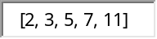
items = ['cake', 'cookie', 'bread']
total_items = items + ['biscuit', 'tart']
print(total_items) 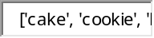
orders = ['daisies', 'periwinkle']
orders.append('tulips')
print(orders) 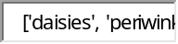
owners_names = ['Jenny', 'Sam', 'Alexis']
dogs_names = ['Elphonse', 'Dr. Doggy DDS', 'Carter']
owners_dogs = zip(owners_names, dogs_names)
print(list(owners_dogs)) 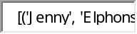
items = [1, 2, 3, 4, 5, 6]
print(items[:4]) 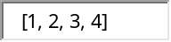
print(items[2:]) 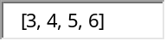
knapsack = [2, 4, 3, 7, 10]
size = len(knapsack)
print(size) 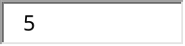
cnt = knapsack.count(7)
print(cnt) 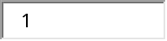
exampleList = [4, 2, 1, 3]
exampleList.sort()
print(exampleList)
soups = ['minestrone', 'lentil', 'pho', 'laksa']
print(soups[-1]) 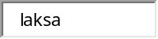
print(soups[-3:]) 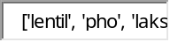
print(soups[:-2]) 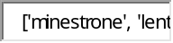

Link:
http://103.53.53.18/mod/hvp/view.php?id=316

Result:
Thus the output for the given program was obtained.

